## What is Selenium?

Selenium is a free (open source) automated testing tool for web applications across different browsers and platforms.

**Selenium has four components.**

* Selenium Integrated Development Environment (IDE)
* Selenium Remote Control (RC)
* WebDriver
* Selenium Grid

**Brief Introduction Selenium IDE**

Selenium Integrated Development Environment (IDE) is the **simplest framework** in the Selenium suite and is **the easiest one to learn**. It is a **Firefox plugin** that you can install as easily as you can with other plugins. However, because of its simplicity, Selenium IDE should only be used as a **prototyping tool**. If you want to create more advanced test cases, you will need to use either Selenium RC or WebDriver.

[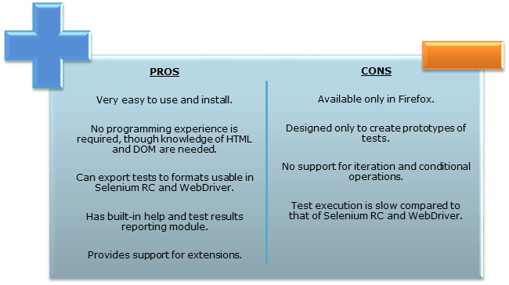](https://www.guru99.com/images/SeleniumIDEProCon.png)

**Brief Introduction Selenium Remote Control (Selenium RC)**

Selenium RC was the **flagship testing framework** of the whole Selenium project for a long time. This is the first automated web testing tool that **allowed users to use a programming language they prefer**. As of version 2.25.0, RC can support the following programming languages:

* [Java](https://www.guru99.com/java-tutorial.html)
* [C#](https://www.guru99.com/c-tutorial.html)
* [PHP](https://www.guru99.com/php-tutorials.html)
* Python
* Perl
* Ruby

[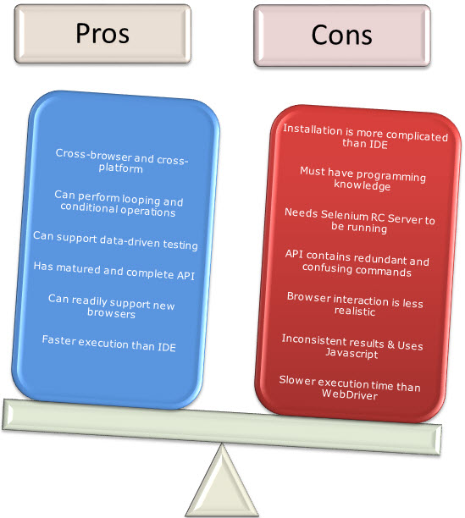](https://www.guru99.com/images/RCProCon.jpg)

**Brief Introduction WebDriver**

The WebDriver proves itself to be **better than both Selenium IDE and Selenium RC** in many aspects. It implements a more modern and stable approach in automating the browser's actions. WebDriver, unlike Selenium RC, does not rely on JavaScript for Automation. **It controls the browser by directly communicating with it.**

The supported languages are the same as those in Selenium RC.

* Java
* C#
* PHP
* Python
* Perl
* Ruby

[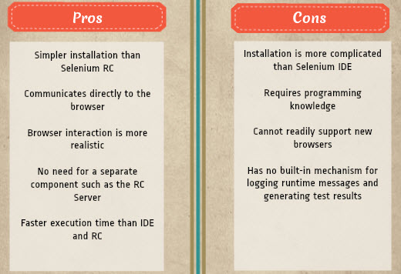](https://www.guru99.com/images/pros_cons_-_webdriver.jpg)

**Selenium Grid**

Selenium Grid is a tool **used together with Selenium RC to run parallel tests** across different machines and different browsers all at the same time. Parallel execution means running multiple tests at once.

**Features:**

* Enables **simultaneous running of tests** in **multiple browsers and environments.**
* **Saves time**enormously.
* Utilizes the **hub-and-nodes** concept. The hub acts as a central source of Selenium commands to each node connected to it.

**Summary**

* The entire Selenium Tool Suite is comprised of four components:
* **Selenium IDE**, a Firefox add-on that you can only use in creating relatively simple test cases and test suites.
* **Selenium Remote Control**, also known as **Selenium 1**, which is the first Selenium tool that allowed users to use programming languages in creating complex tests.
* **WebDriver**, the newer breakthrough that allows your test scripts to communicate directly to the browser, thereby controlling it from the OS level.
* **Selenium Grid** is also a tool that is used with Selenium RC to execute parallel tests across different browsers and operating systems.
* Selenium RC and WebDriver was merged to form **Selenium 2**.
* Selenium is more advantageous than QTP in terms of **costs and flexibility**. It also allows you to **run tests in parallel**, unlike in QTP where you are only allowed to run tests sequentially.

**Locators: - Locators are used to interact elements in a browser page.**

<https://selenium-python.readthedocs.io/locating-elements.html>

**Locater Types:**

**1. Locate Element by Name**

**2. Locate Element by ID**

**3. Locate Element by Link Text**

**4. Locate Element by Partial Link Text**

**5. Locate Element by XPath**

**6. Locate Element by CSS Selector**

**7. Locate Element by Tag name**

**8. Locate Element by Classname**